Student Resources for Virtual Learning

Resources for Pickup:

Textbooks
- Students in grades K-5 will receive consumable textbooks.
- A pack of Scholastic reading books.
Technology
- If requested, at least one device to connect to the internet per household
  - If available, we will provide technology to siblings as well at a later date
- If requested, a Wi-Fi internet hotspot (subject to availability from the district)

Curbside Resource Pick Up Schedule
- See the schedule below for pickup times.
  - NOTE: Families with students in multiple grade levels will be able to pick up supplies for all students at once.

Grade Level | Pick Up Dates/Times
3rd Grade | Thursday, August 27th from 9:00-12:00
4th Grade | Thursday, August 27th from 12:00-3:00
5th Grade | Friday, August 28th from 9:00-12:00
2nd Grade | Friday, August 28th from 12:00-3:00
Kindergarten and Pre-K | Thursday, September 3rd from 9:00-12:00
1st Grade | Thursday, September 3rd from 12:00-3:00

Prepare to Pick Up

Driving Up

1
    - 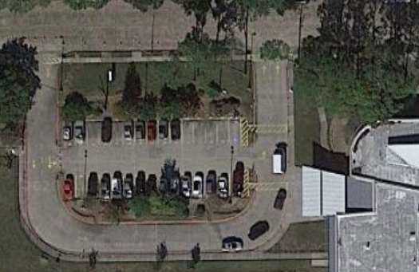Wear a face mask
Jason Street
1
2
Circle Drive
    - Stay in your vehicle
    - Enter the Circle Drive and pull forward to meet Herod staff
    - Leave enough room in front of your car to pull out of the line
    - Take out a pen if you have one

Walking Up
2
    - Wear a face mask
    - Line up next to the column closest to the playground
    - Maintain social distancing (6 feet apart from others)
    - Bring a pen if possible

